MALAYAN COLLEGES MINDANAO (A MAPUA SCHOOL)
Gen. MacArthur Highway, Matina, Davao City
College of Engineering and Architecture
Department of Computer Engineering


CPE143L
Web Design and Development (Laboratory)

Byte Bysters

Proponents:
Angela Nicole K. Campogan
Jeshemy Marie A. Tan

Submitted to:
Engr. Rex Amido
Professor

November 6, 2026

Byte Busters: An Online Electronics Components and Project Kit Store
Angela Nicole K. Campogan and Jeshemy Marie A. Tan

Introduction
Byte Busters is an e-commerce website that sells electronic components and ready-made project kits. It is built for engineering students and hobbyists who need parts for their school projects and personal builds. The idea was inspired by the Davao Times, and the system is developed using HTML, CSS, JavaScript, and SQL.

Problem Statement
Students who need electronic parts often have to travel across town to different shops or order from abroad and wait for delivery. A single project may need parts from many sellers, so finding everything takes time, effort, and money. Students also often lack a complete guide for how the parts fit together, which makes small projects harder to start.

Objectives
The project aims to give students and hobbyists one place to find and buy electronic components with local stock and fast delivery. It also aims to offer curated project kits that already contain the exact parts needed, together with a wiring guide and sample code. Lastly, it aims to help the store owner manage products, orders, and stock accurately through an admin dashboard.

Proposed Solution
The website lets customers browse components and kits, add them to a cart, and place orders. Each kit includes the exact parts, a printable wiring guide, and sample code, so a buyer can start building right away. The inventory count drops automatically whenever an order is placed, and buying a kit lowers the stock of each part inside it. This keeps the displayed stock accurate and prevents over-ordering.

Key Features
For users:
- Product page with search and category filters
- Product details with specifications and a printable kit guide
- Shopping cart (add, remove, and update quantity)
- User registration and login
- Order checkout and order history
For the admin:
- Dashboard to add, edit, and delete products and kits
- Update stock levels
- View and update order status
- Low-stock and "out of stock" labels

Database Design
The database is managed in phpMyAdmin and is made up of seven main tables. The users table stores account details and role (customer or admin). The categories table holds product groups. The products table stores name, description, price, stock, image, and category. The kits table stores the bundle name, price, and guide file, while kit_items links each kit to its parts and quantities. The orders table records the customer, date, total, and status, and order_items records the items bought, their quantities, and prices.
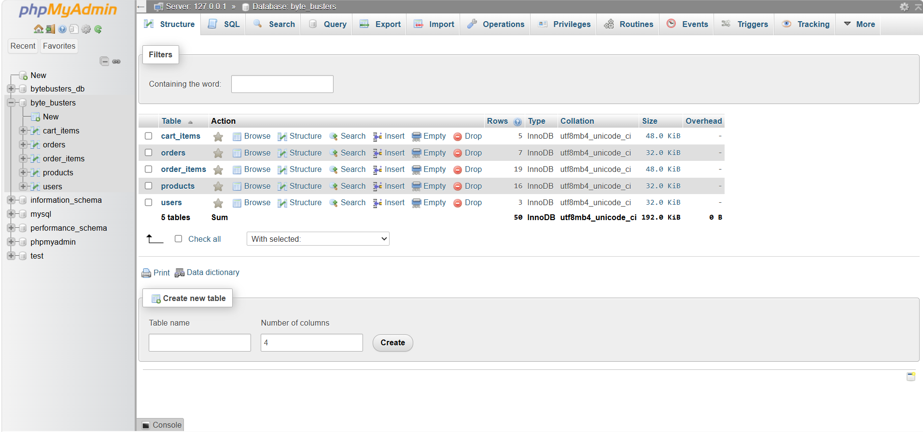
Figure 1. Database

Technologies and Tools
The website is built with HTML, CSS, JavaScript, and SQL. phpMyAdmin is used for the database, IntelliJ IDEA for coding, and Claude, Gemini, and YouTube tutorials as development and learning aids.

AI Declaration
The team, Angela Nicole K. Campogan and Jeshemy Marie A. Tan, enrolled in the CPE143L course, used AI tools during this project. Claude was used to help write and debug the code, and Gemini was used to generate the product photos for the website. The team reviewed and tested the output and takes responsibility for the final work.

Challenges and Lessons Learned
The team faced time constraints, difficulty connecting the database, finding suitable product pictures, UI problems, building the admin dashboard, and finding and following tutorials. Through these, the team learned how to properly create a database in phpMyAdmin, how e-commerce websites operate, and how to manage the number of pages in a website.

Expected Outcome and Future Improvements
The expected outcome is a working online store where students can easily find local electronic parts and kits, and where the admin can keep products, stock, and orders organized. For future improvements, the team plans to add online payment methods, an AI chatbot for product recommendations, a more complete admin dashboard, and a more proper database execution.

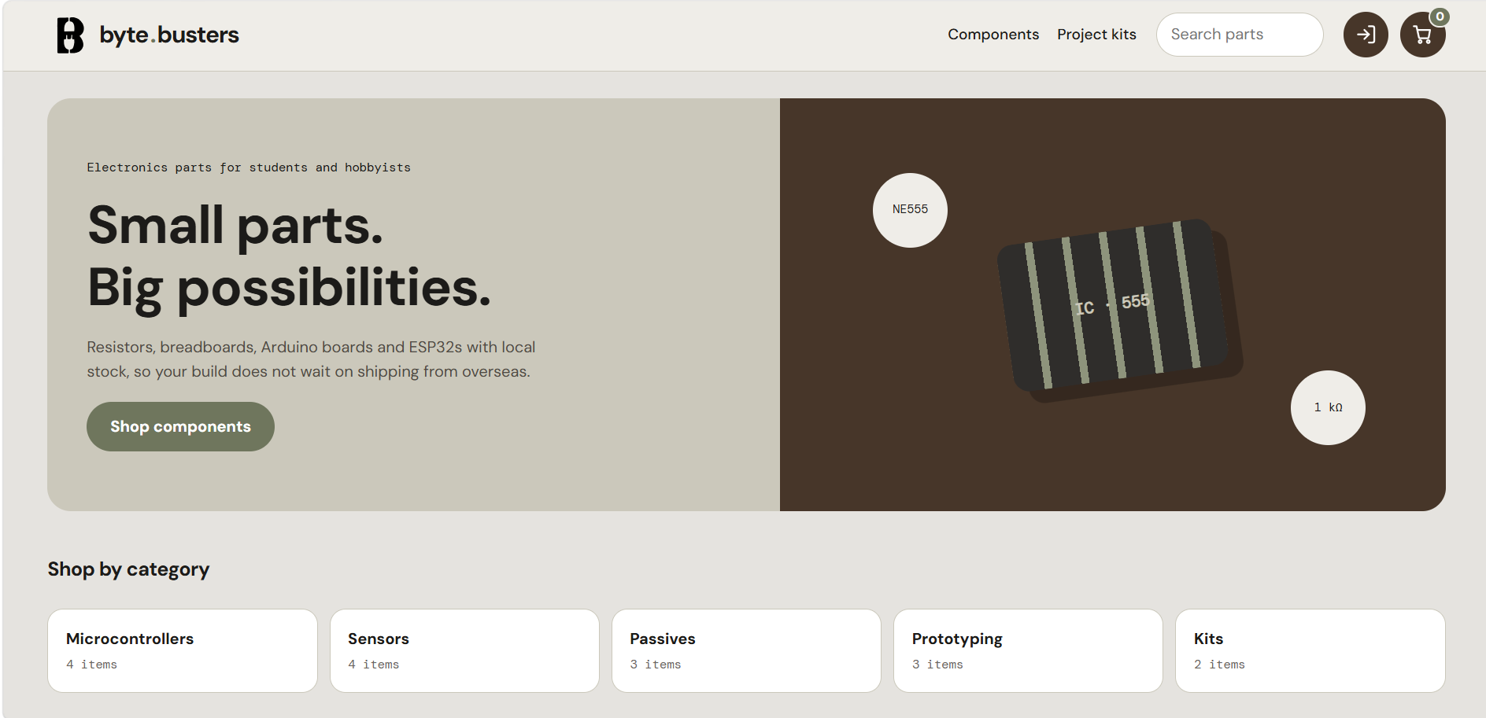
Figure 2. Website Landing Page

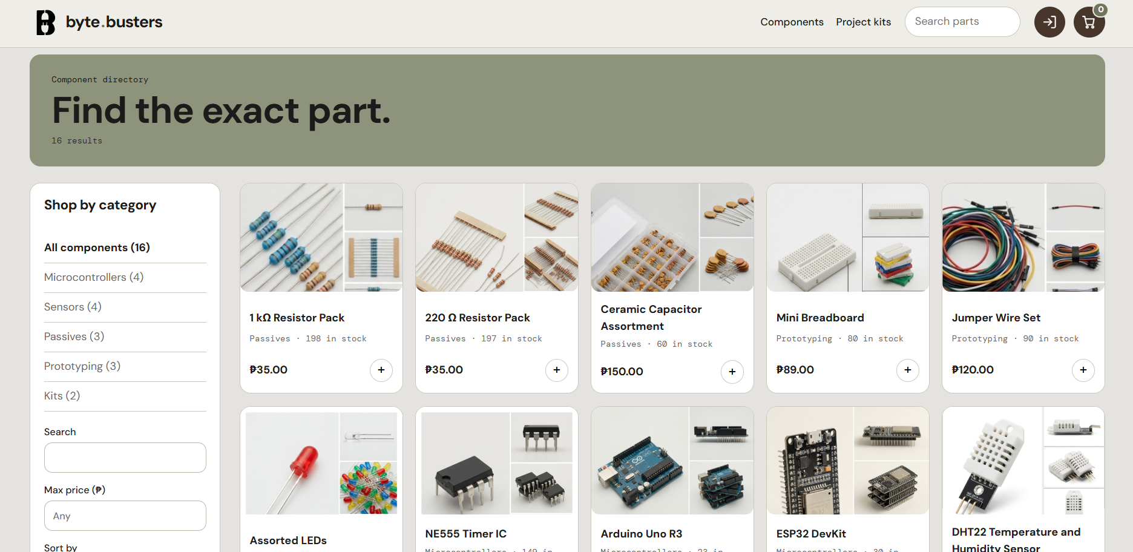
Figure 3. Website Components Page

